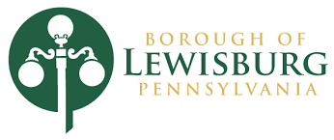

MAYORAL PROCLAMATION

“Recognizing Halloween in the Borough of Lewisburg” Proclamation
October 31, 2025

WHEREAS, Halloween is a long-celebrated tradition bringing together children, families, and neighbors in the spirit of fun, creativity, and community; and

WHEREAS, the Borough of Lewisburg values traditions that foster connection and joy, and Halloween provides an opportunity for residents of all ages to gather in friendship, imagination, and seasonal festivity; and

WHEREAS, Halloween celebrations encourage creativity through costumes, decorations, and storytelling, while also reminding us of the importance of safety, kindness, and respect for neighbors; and

WHEREAS, the Borough of Lewisburg is proud to support community traditions that highlight our small-town spirit and create lasting memories for all who call Lewisburg home;

NOW, THEREFORE, I, Kendy Alvarez, Mayor of the Borough of Lewisburg, do hereby proclaim October 31, 2025, as Halloween in Lewisburg, and encourage all residents to celebrate safely, enjoy the season, and embrace the spirit of community that makes Lewisburg a truly special place to live, work, and play.

IN WITNESS WHEREOF, I have hereunto set my hand and caused the Seal of the Borough of Lewisburg to be affixed this 16th day of September, 2025.

Kendy Alvarez
Mayor, Borough of Lewisburg
September 16, 2025

